**How to Get Your OpenAI API Key**

**Step 1: Sign In or Sign Up**

* If you have an OpenAI account, log in.
* If not, sign up for a new account.

**Step 2: Set Up Billing**

OpenAI uses a pay-per-use model for its API services. To activate your API key, set up billing:

1. Go to the **this Link** for the **'Billing Overview'**.
   * <https://platform.openai.com/settings/organization/billing>
2. Go to the **Billing** section and click **'Add payment details'**.

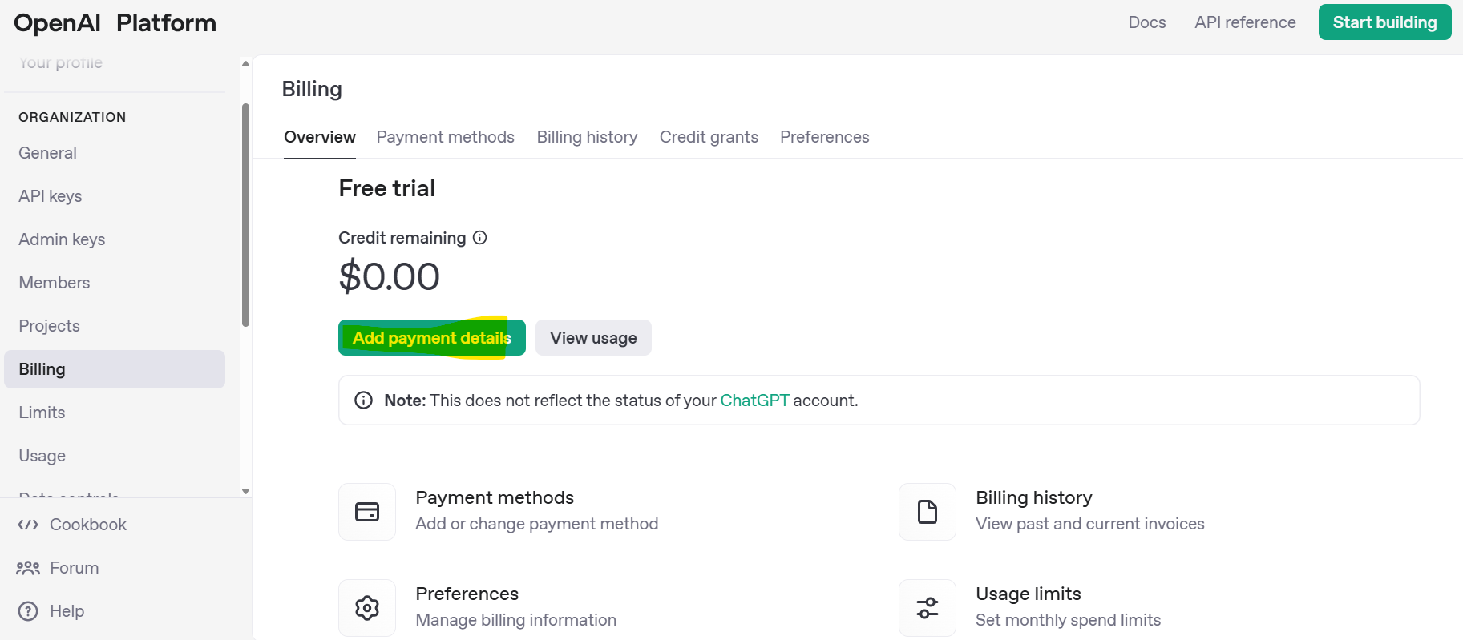

1. Enter your payment details and click **'Continue'**.

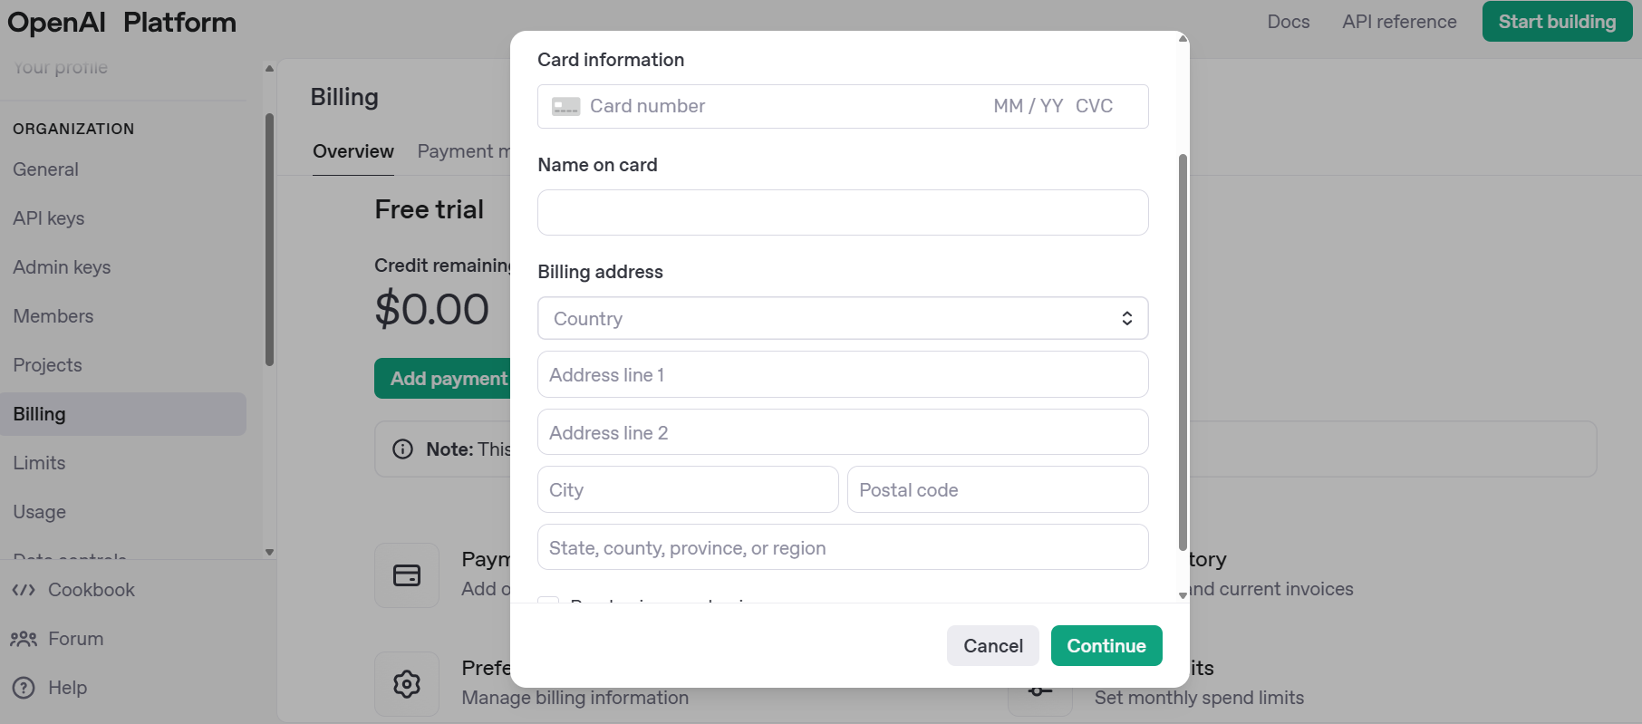

1. On the next screen, you will see payment options:
   * **A:** Enter an amount between $5 and $100 to add an initial credit.
   * **B:** Set up automatic recharges (optional).
   * **C:** Choose a minimum balance for automatic recharges.
   * **D:** Set the total balance for account recharges.
2. Click **'Continue'** after making your selections.

1. On the final screen, review your details and click **'Confirm payment'**.

**Step 3: Generate a New API Key**

1. Visit OpenAI's API platform link
   * <https://platform.openai.com/settings/organization/api-keys>
2. Click **'+ Create new secret key'**.

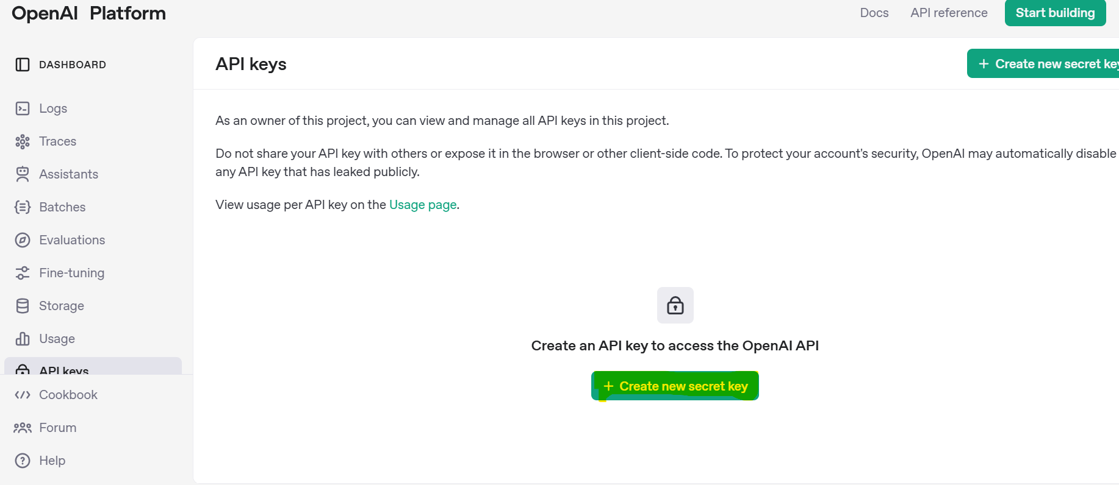

1. Enter a name for your key in the pop-up window.

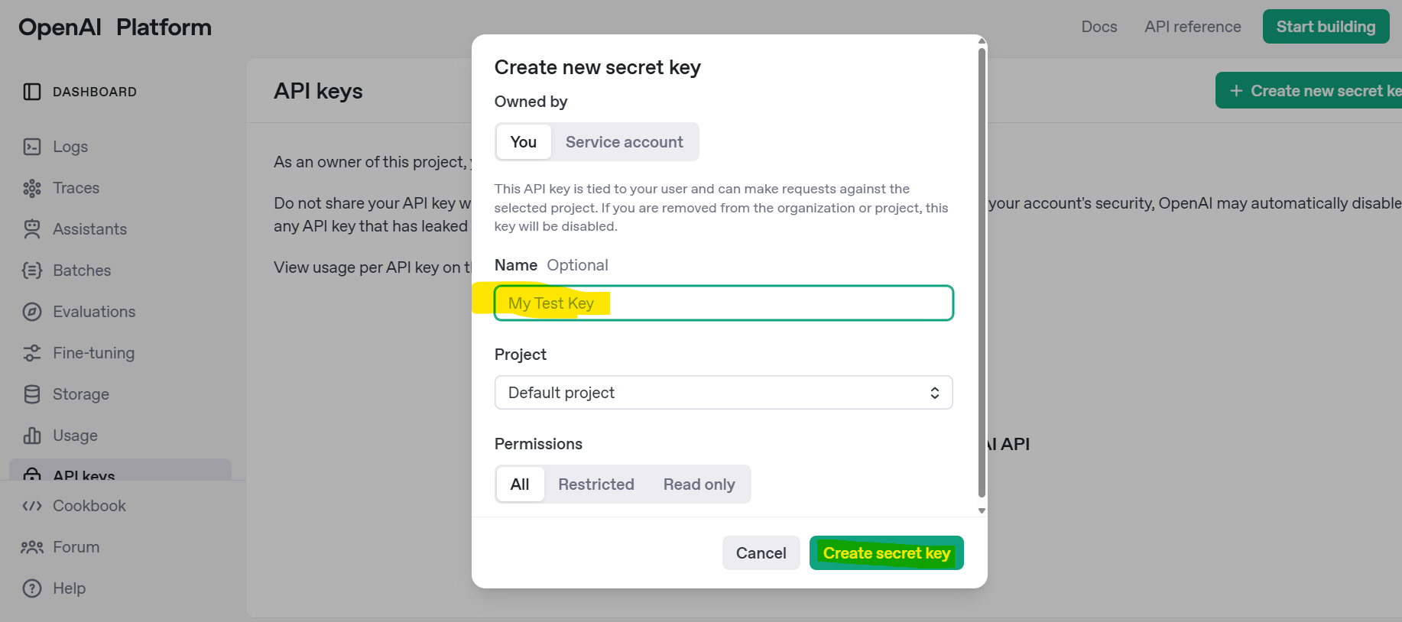

1. Click **'Create secret key'**.
2. Copy your API key and store it safely. You will not be able to view it again.

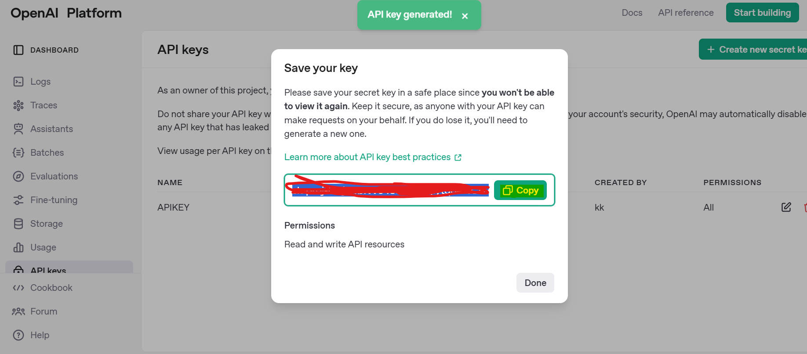

**Pricing**

OpenAI updates its pricing regularly. Check their website for the latest pricing details to find the best plan for you.

**You're all set to start building with ChatGPT!**